SIT-103 DATBASE FUNDAMENTALS
TASK 4.1P DATABSE NORMALISATION
SUBMITTED BY – 224001588 JASVEENA

- DEPENDENCY DIAGRAM

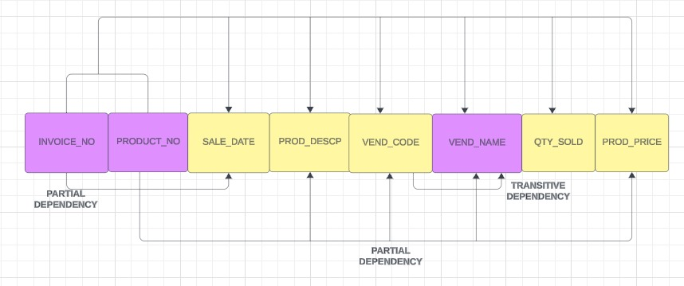

The relation is in 1NF as there is no repeating groups and each record is different and dependant on PK.
- REMOVING PARTIAL DEPENDENCIES
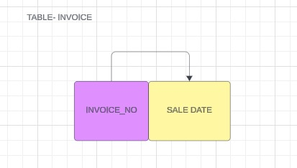
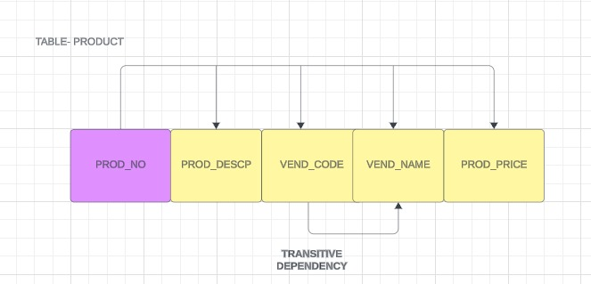
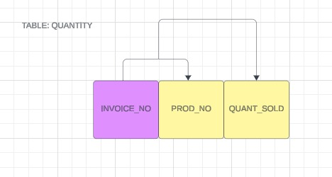
This table meets the criteria for Second Normal Form (2NF) as it also fulfills the requirements for First Normal Form (1NF) and 2NF. It adheres to 1NF because it lacks repeating groups and each record is uniquely identifiable. Furthermore, it satisfies 2NF because there are no partial dependencies; every non-key attribute depends entirely on the full primary key. Although the table has been denormalized for performance optimization, it still complies with 2NF standards.
- REMOVING TRANSITIVE DEPENDENCIES IN ALL TABLES:
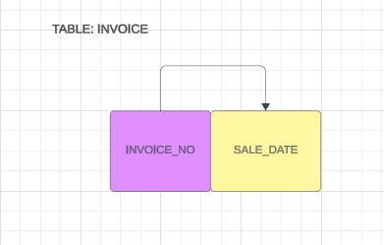

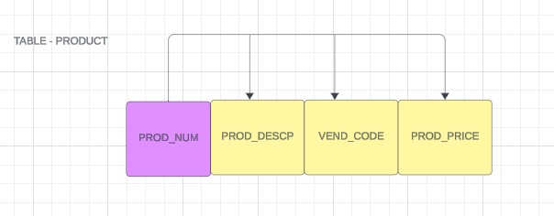

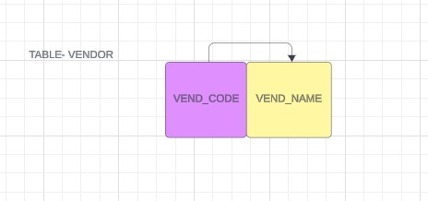

Each table in the dependency diagram has been denormalized to Third Normal Form (3NF) as follows: Firstly, the tables are already in Second Normal Form (2NF). Secondly, they have no transitive or partial dependencies, meaning all non-key attributes are completely dependent on the primary key and do not depend on other non-key attributes. This guarantees that the tables satisfy the 3NF requirements, even though they are in a denormalized state.

- ER DIAGRAM
